AI Agent databricks

1. Zero Shot
2. Multi Shot
3. Chain of thought
4. React(below)

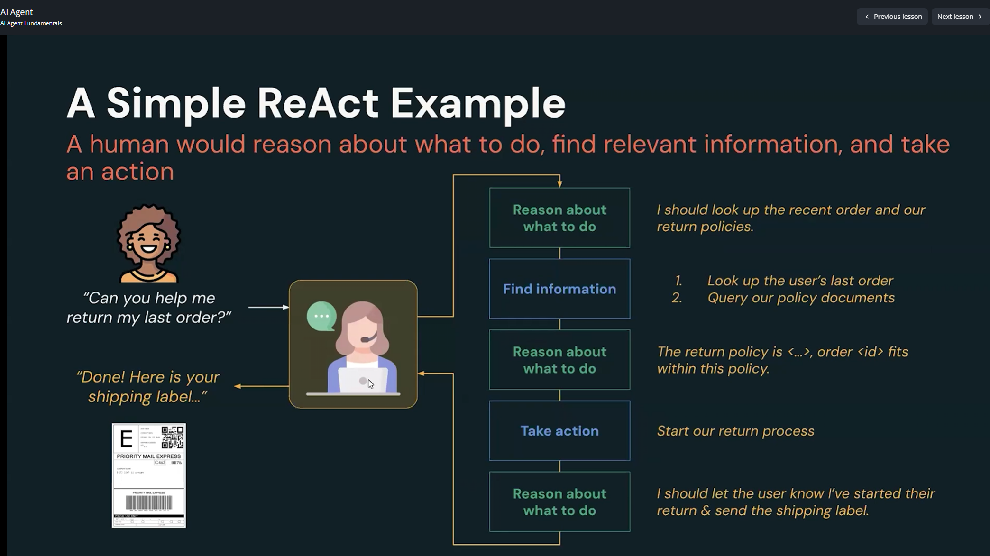

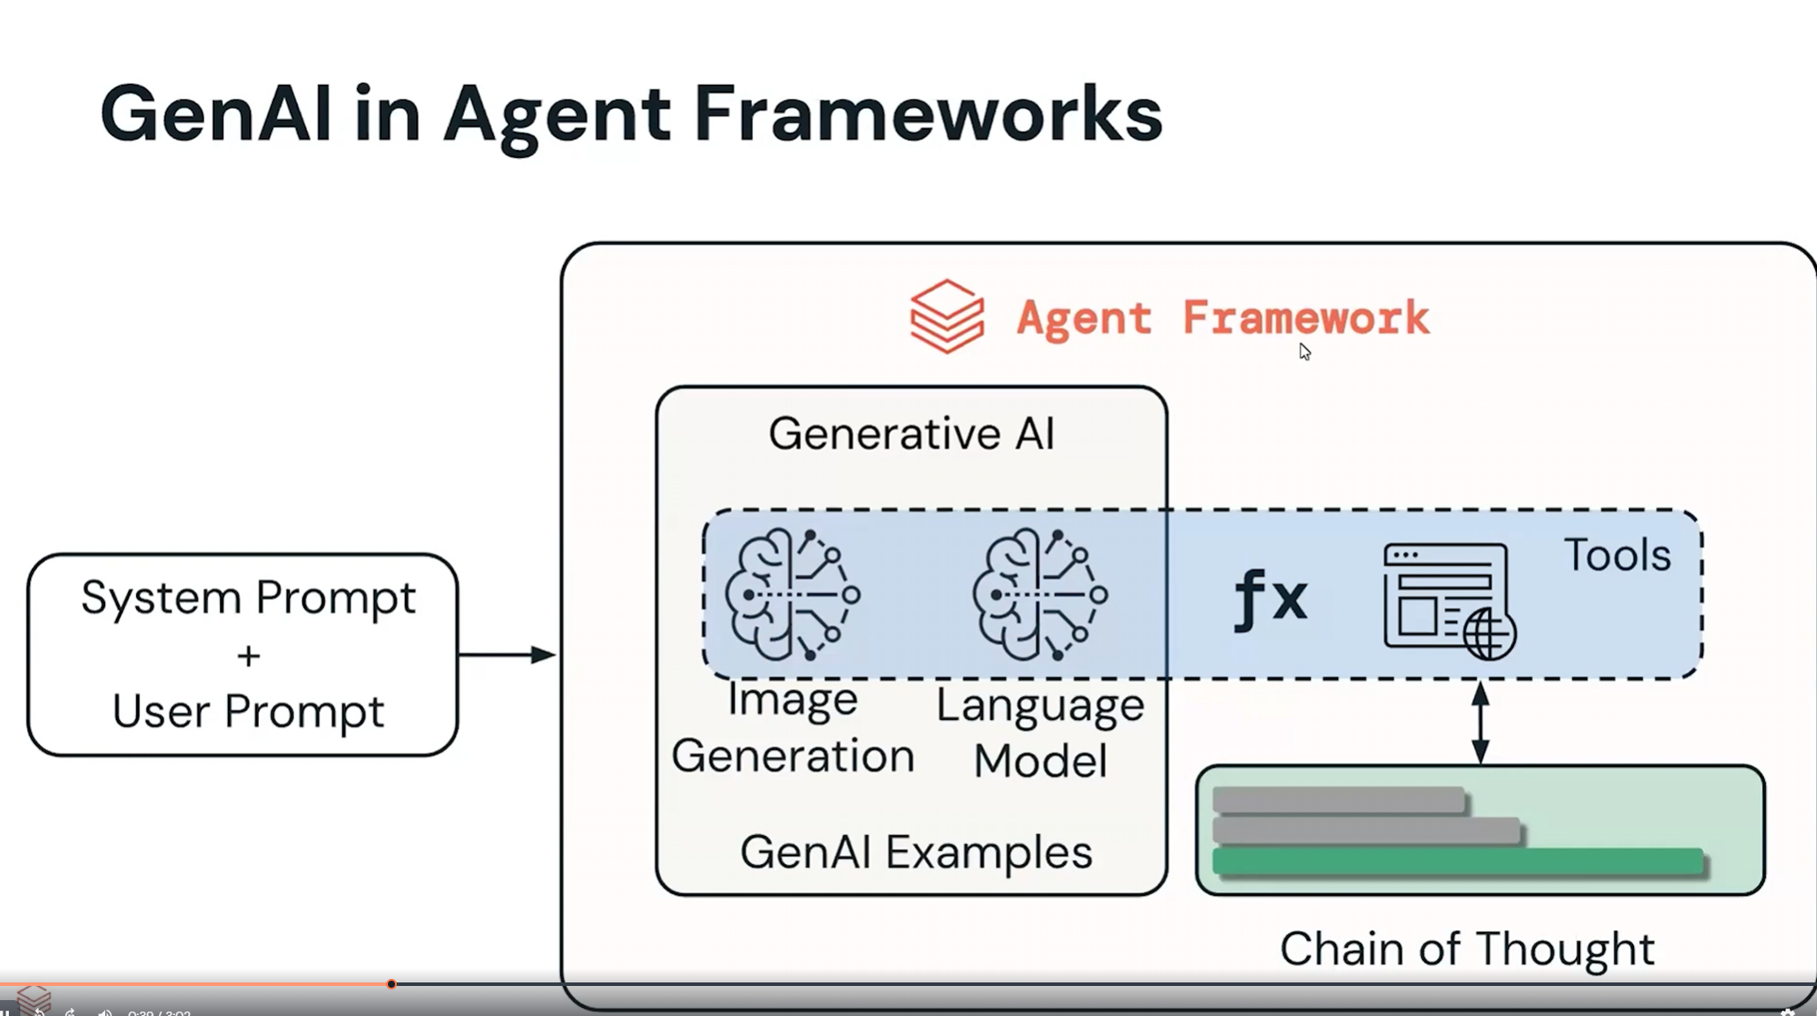

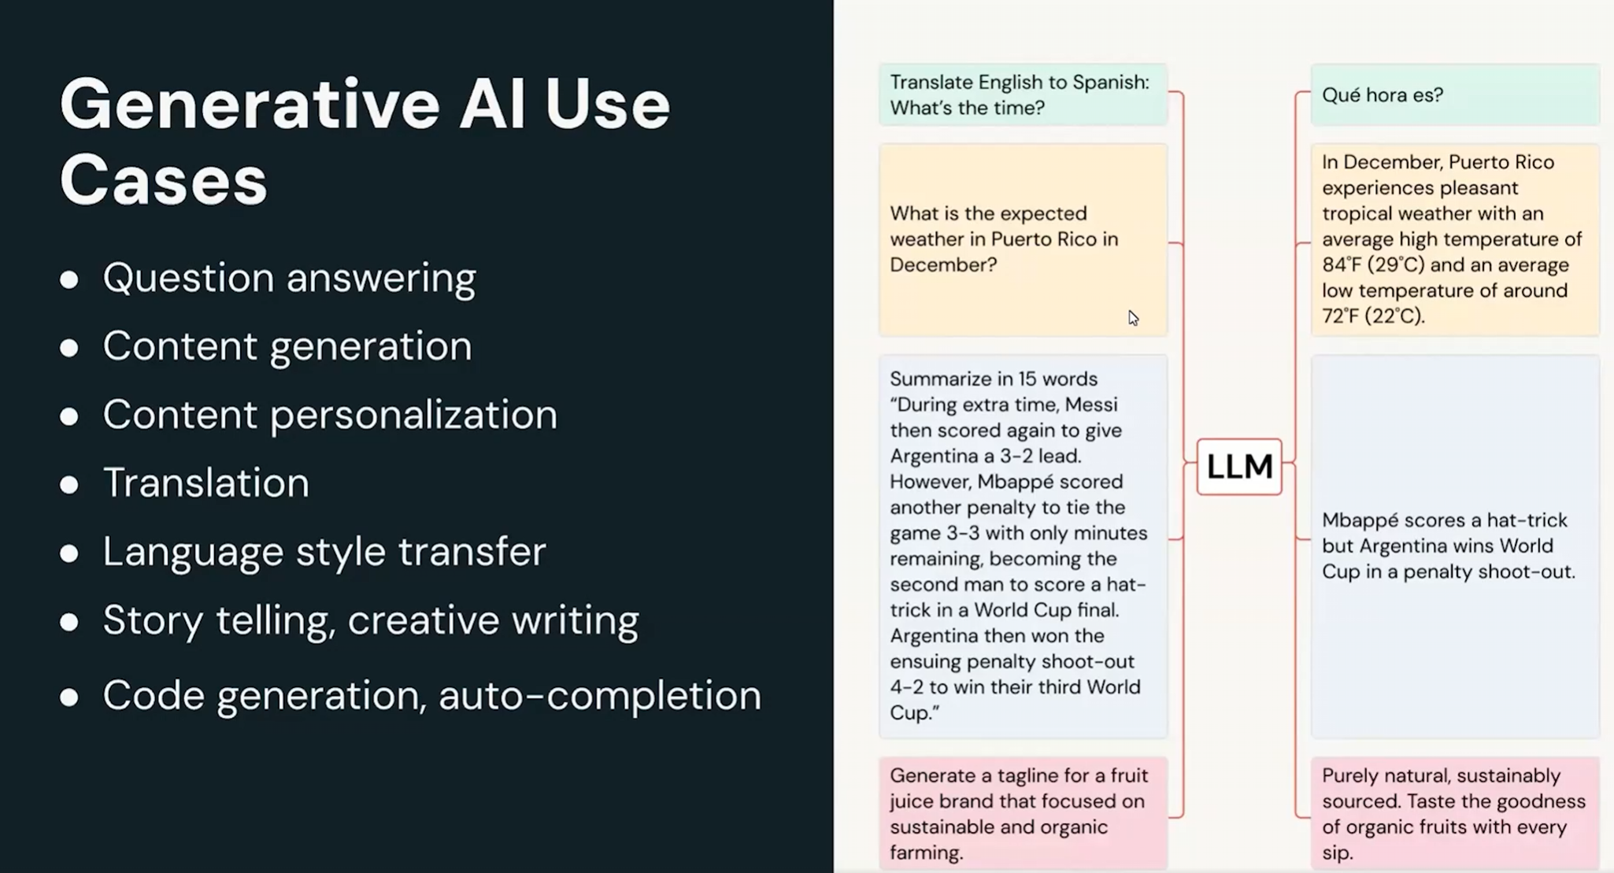

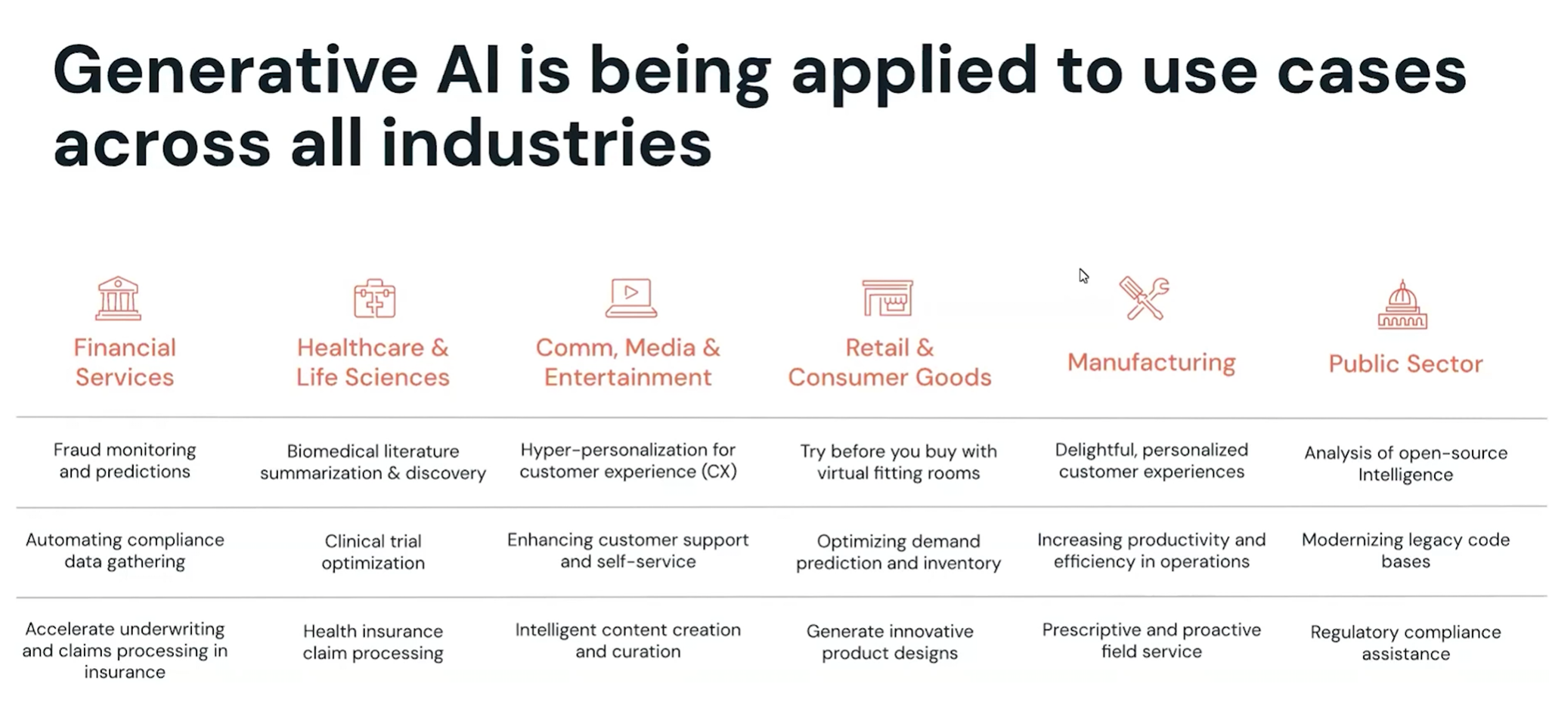

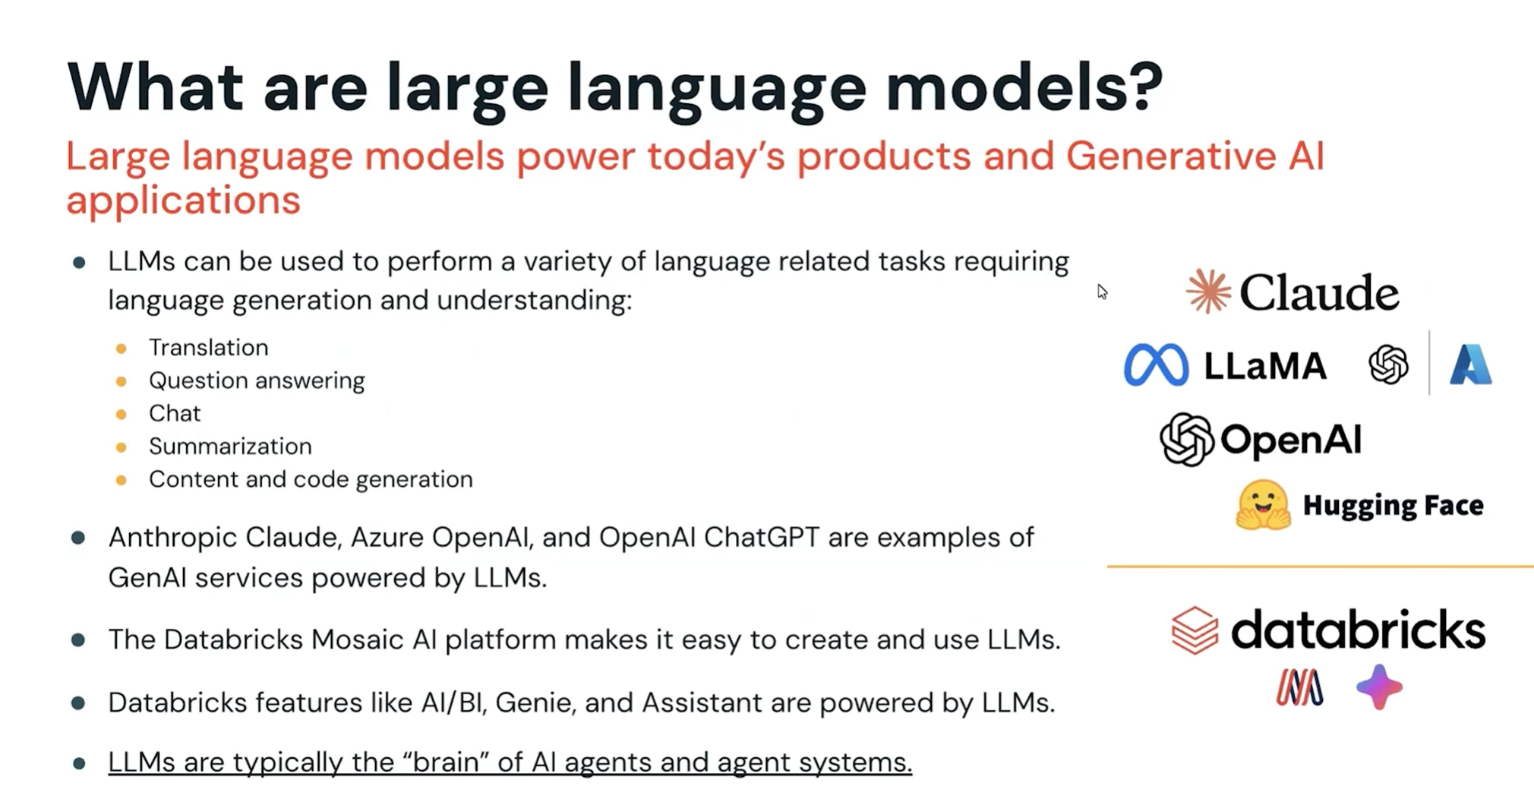

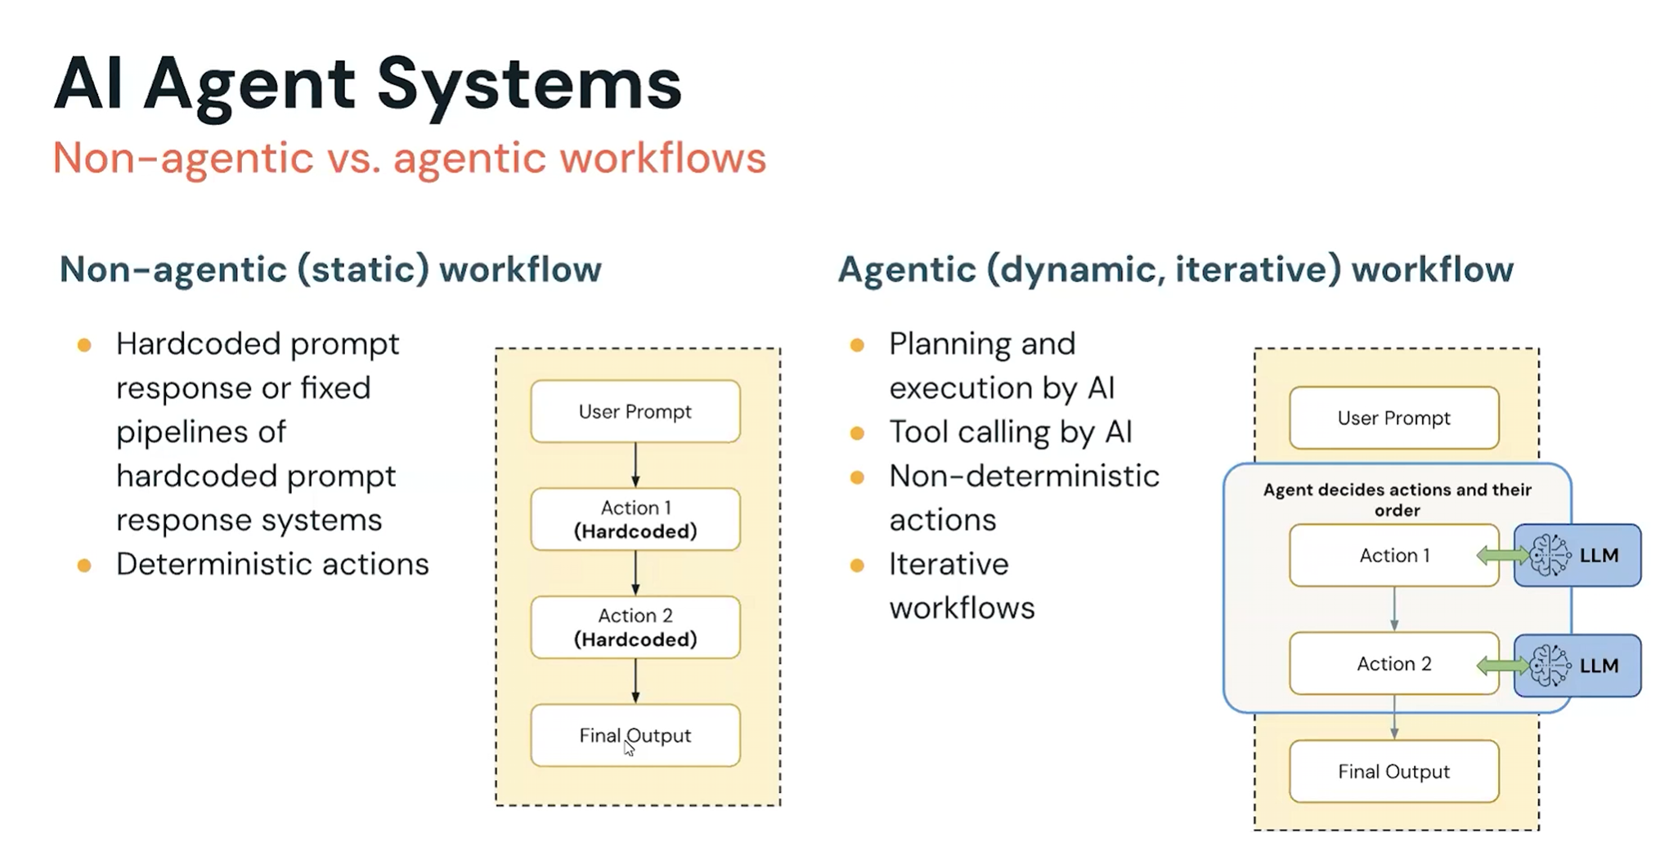

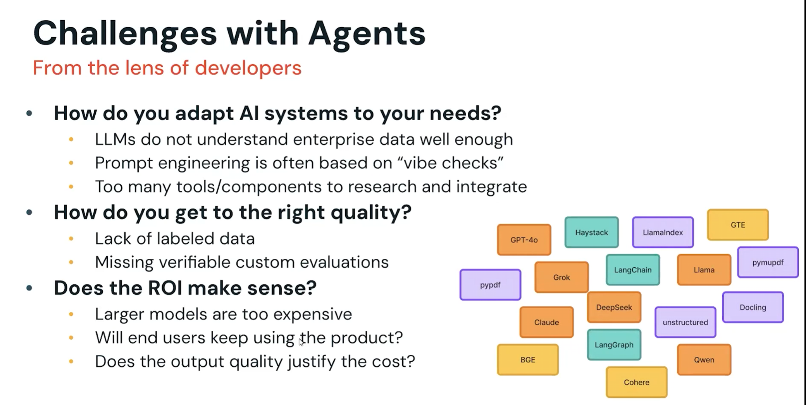

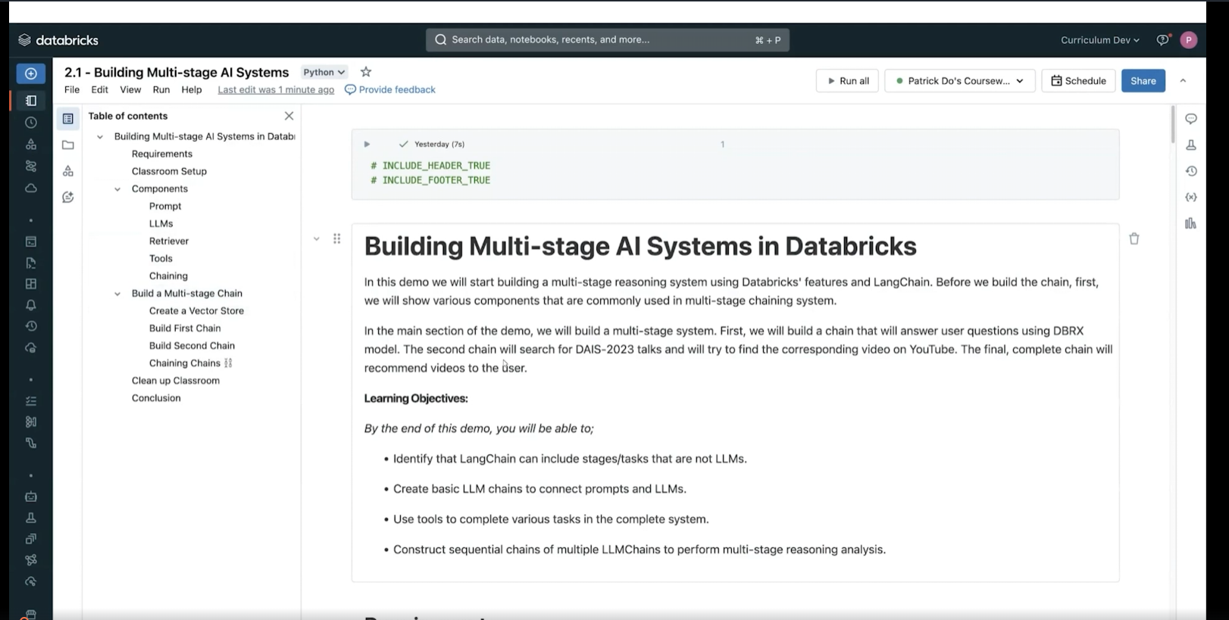

Vector Search

Documentation needed for how to use libraries

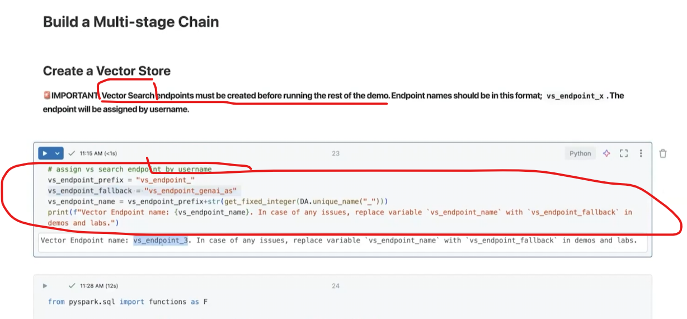

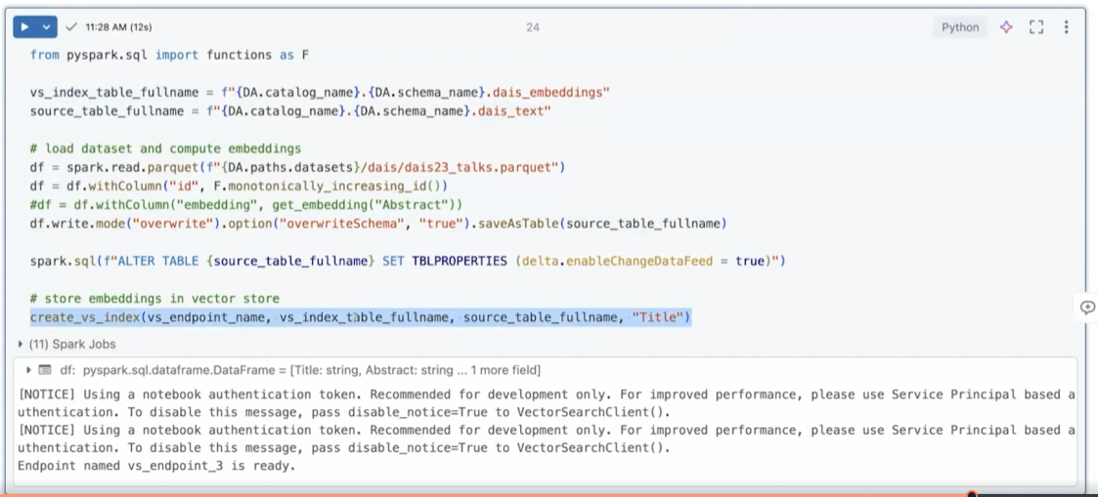

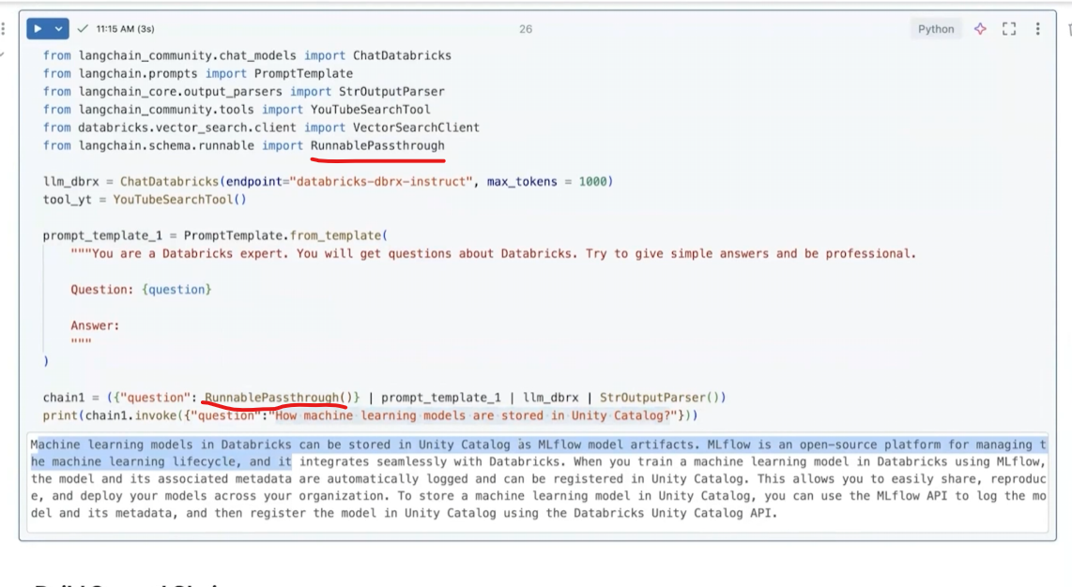

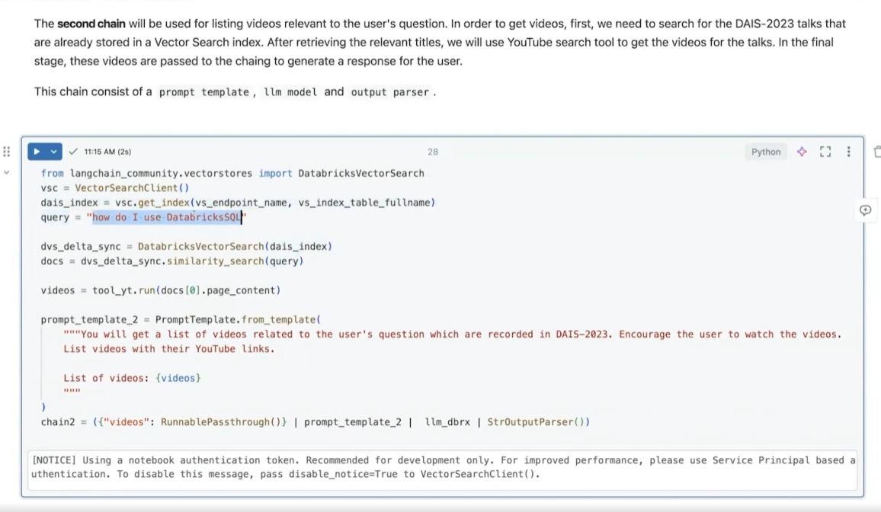

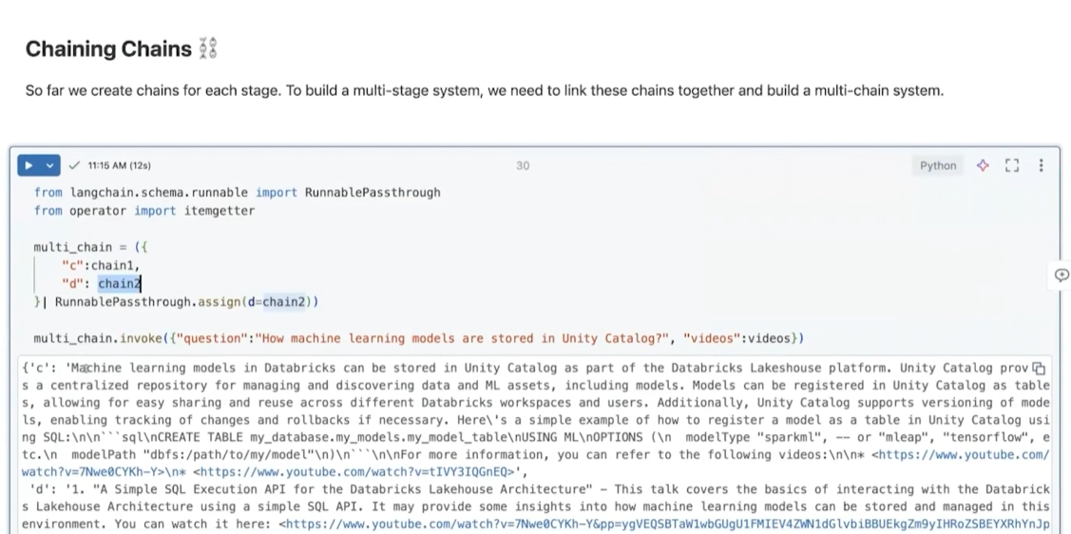

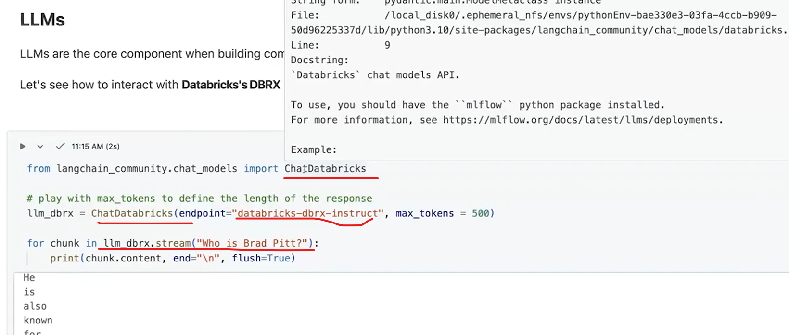

Second Example

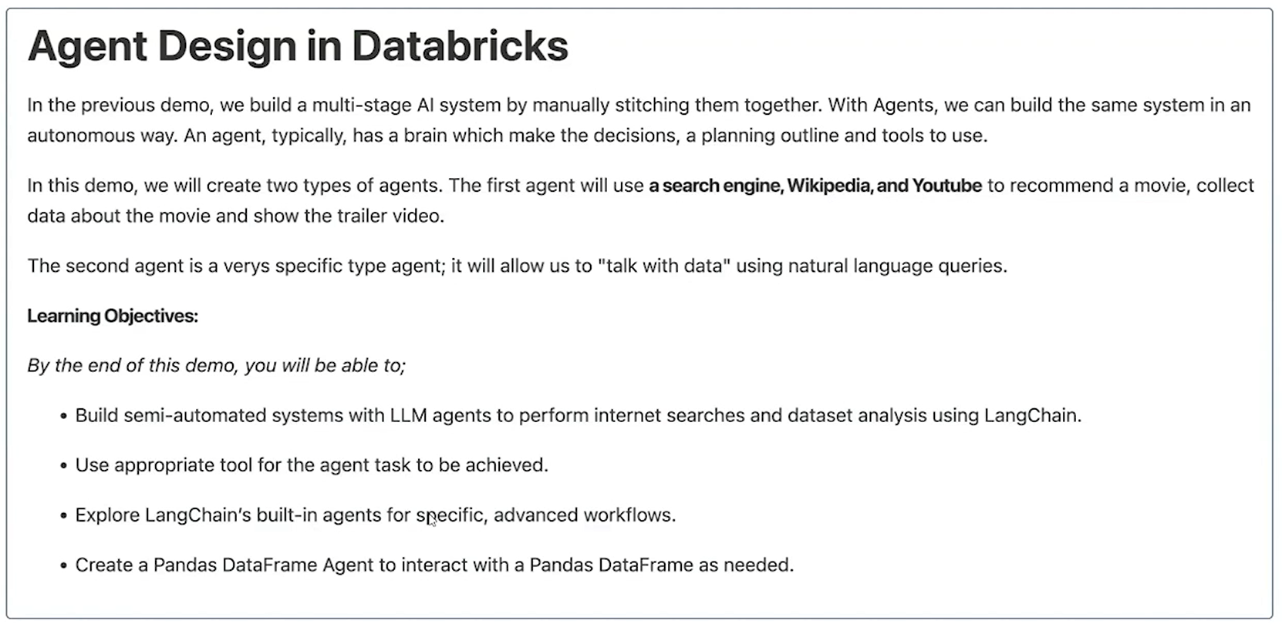

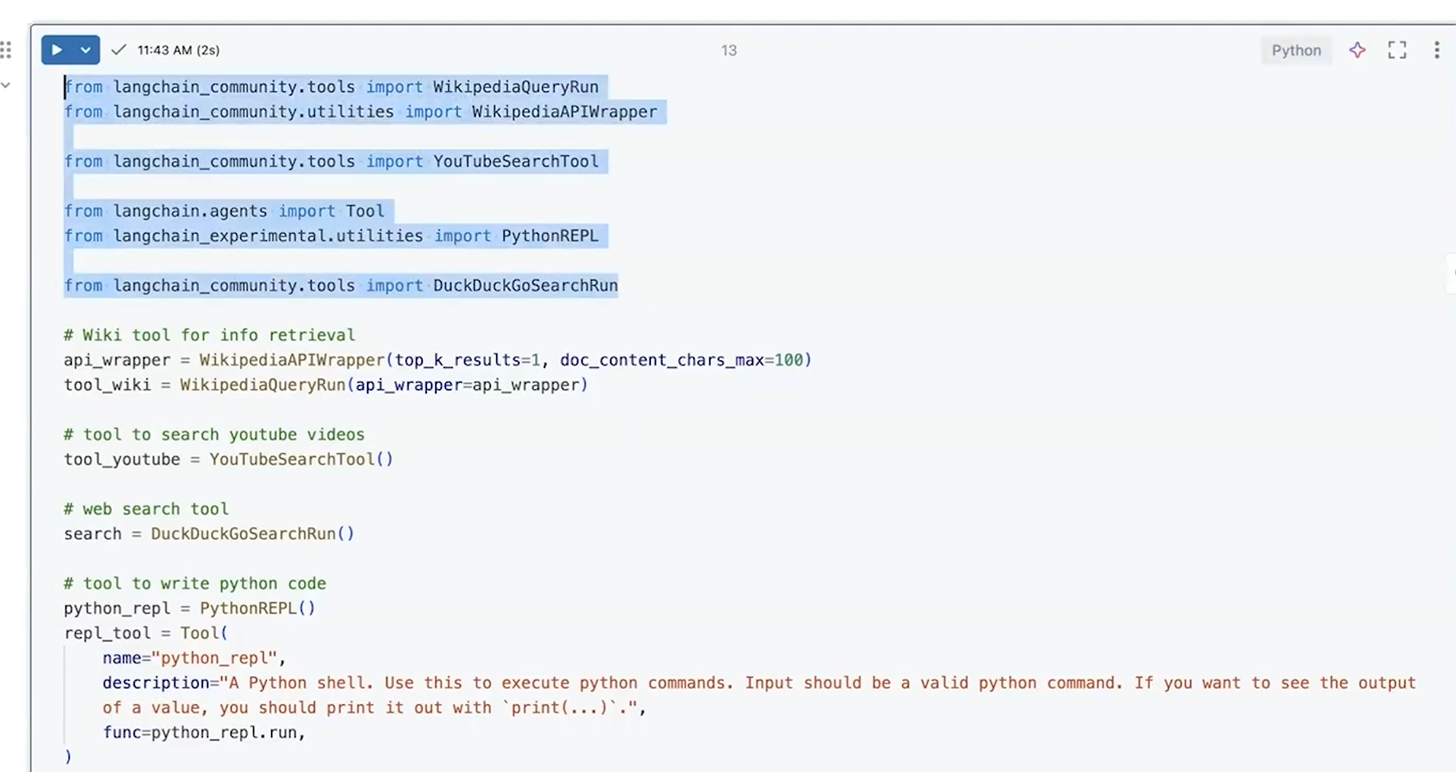

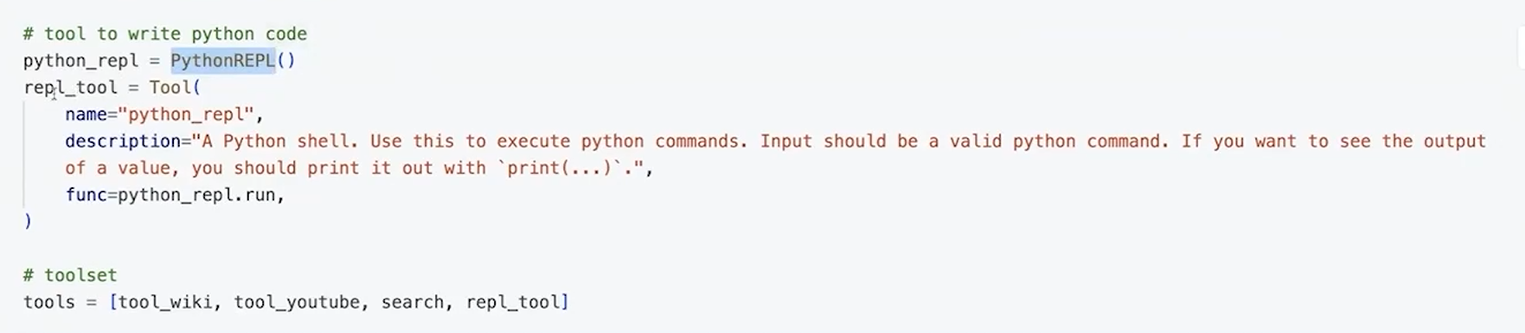

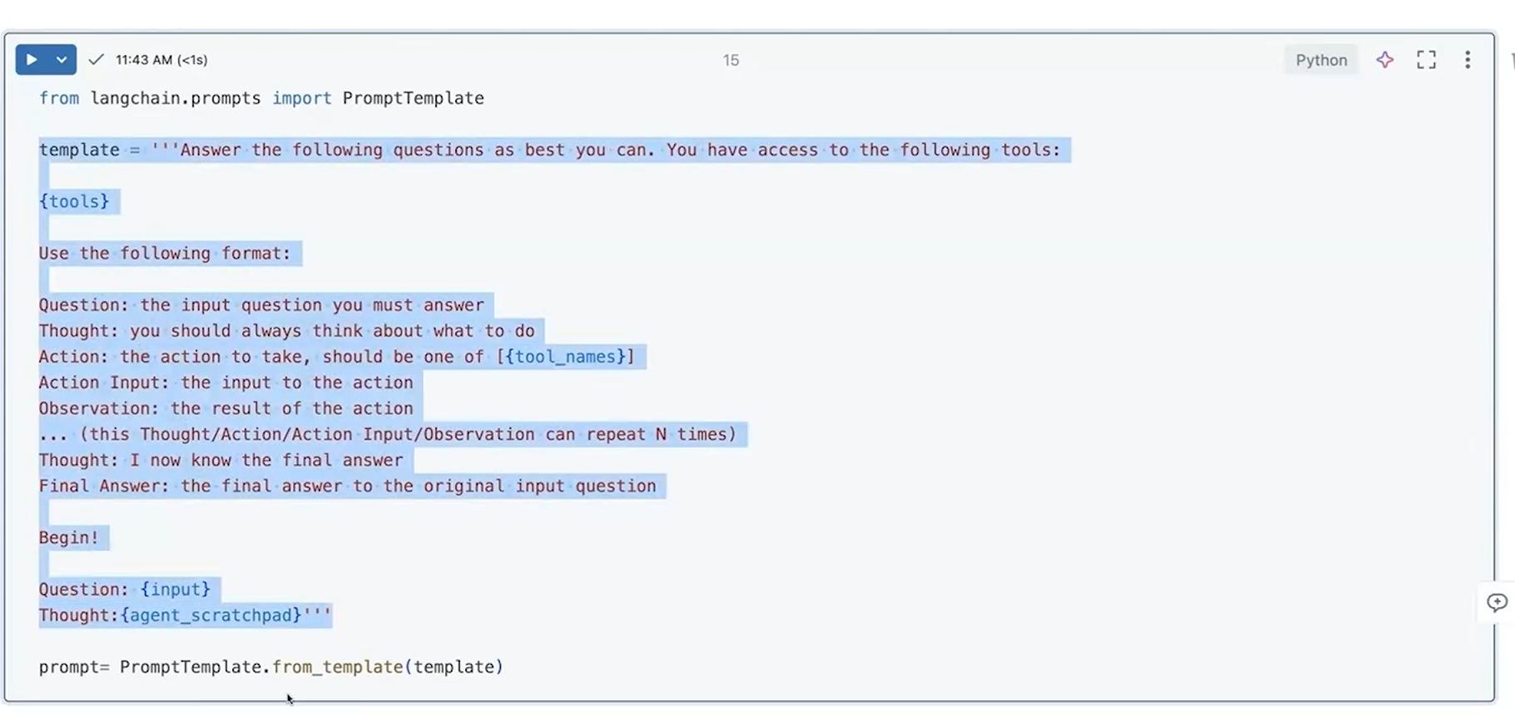

He used a ReAct agent because the task requires multi-step reasoning + dynamic tool usage + observation of results before deciding the next step.

**What ReAct means (important)**

**ReAct = Reason + Act + Observe**

Loop:

Thought → Action → Observation → Thought → Action → …

This is **not marketing**, it’s a control loop.

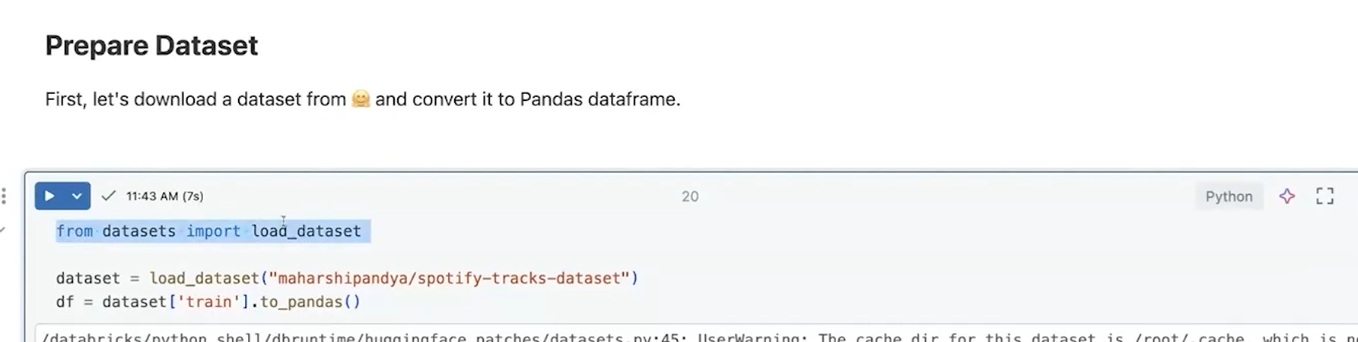

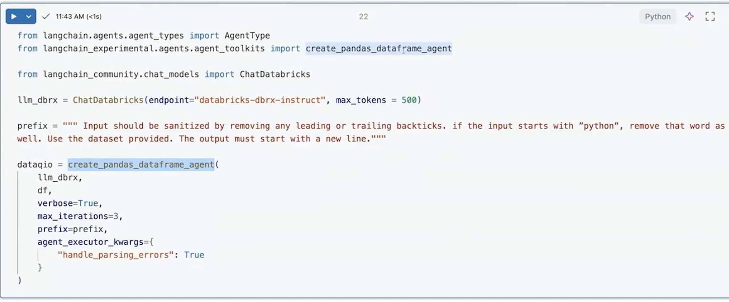

**Crew AI** is explicitly designed around the idea of **collaborative intelligence**:

* Multiple **autonomous AI agents**
* Each agent has a **role, goal, and responsibility**
* Agents **coordinate and collaborate** to solve complex tasks
* Emphasis is on **teamwork**, task delegation, and inter-agent communication

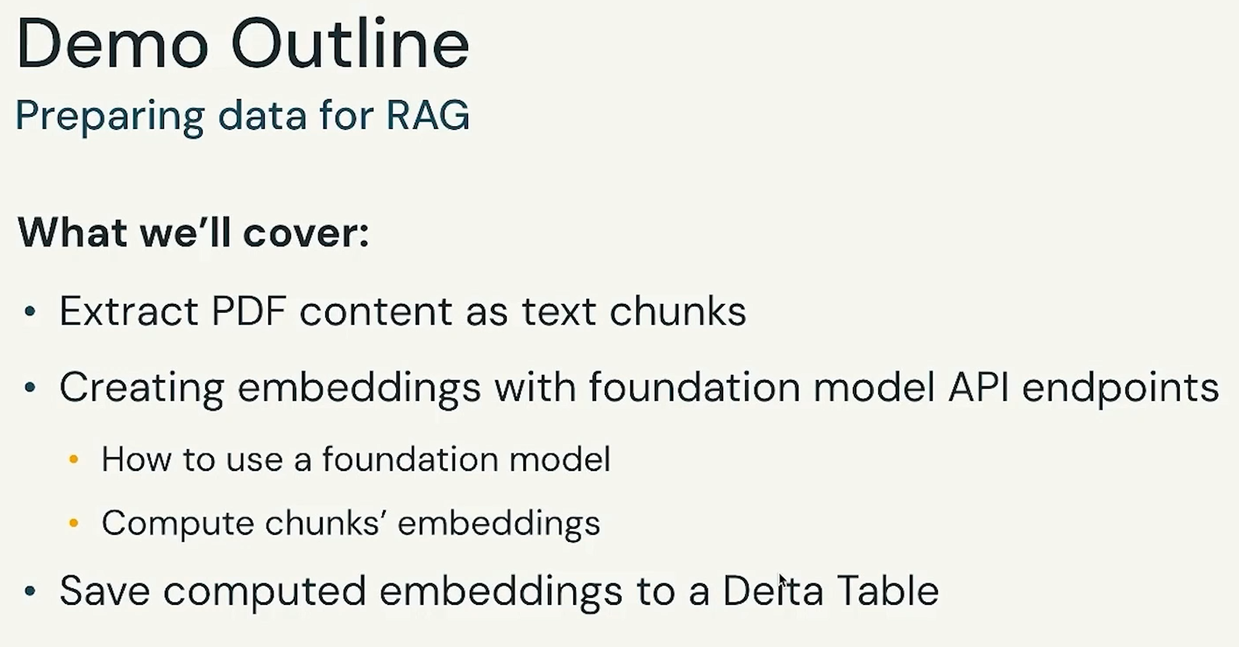

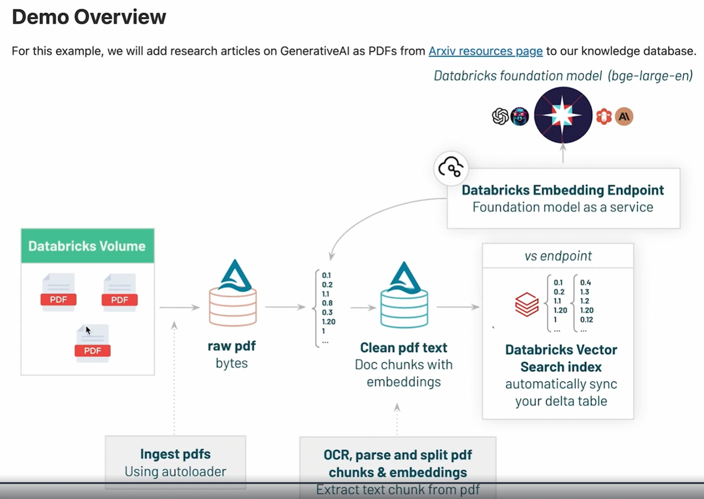

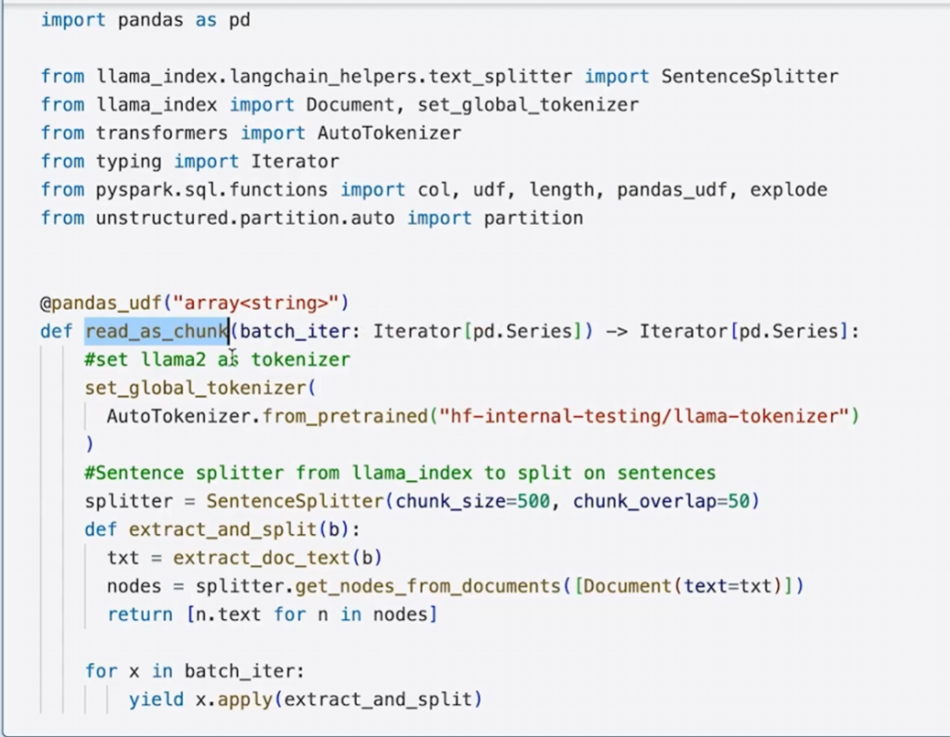

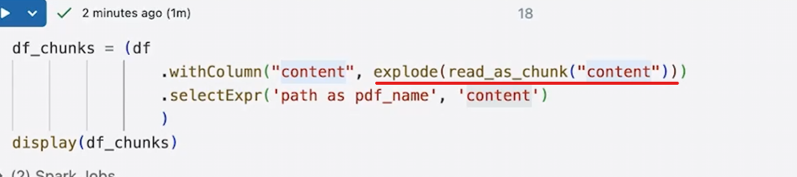

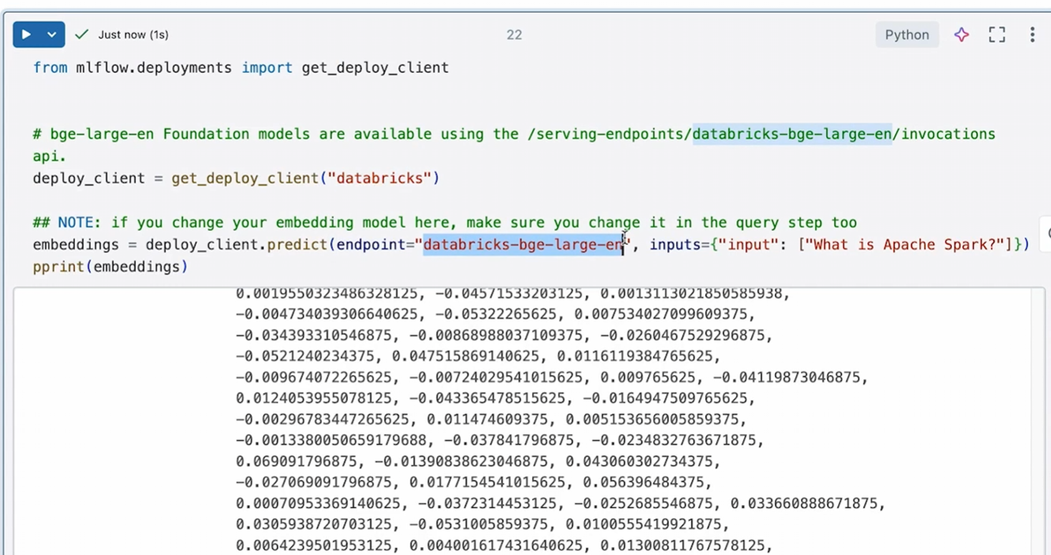

from mlflow.deployments import get_deploy_client

This gives you a generic client that knows how to talk to:

Databricks

SageMaker

Azure ML

etc.

Here, you’ll use it for Databricks.

deploy_client = get_deploy_client("databricks")

This means:

“I want to call models that are deployed on Databricks.”  
Under the hood:

* Uses your Databricks auth
* Knows how to hit Databricks serving endpoints
* Handles request/response formatting

embeddings = deploy_client.predict(

endpoint="databricks-bge-large-en",

inputs={"input": ["What is Apache Spark?"]}

)

his is the **core line**.

What’s happening:

**🔹 endpoint="databricks-bge-large-en"**

* This is a **Databricks-hosted embedding model**
* Based on **BGE (BAAI General Embedding)** family
* Managed and served by Databricks

You did **not** deploy this model — Databricks did.

**inputs={"input": [...]}**

You are sending:

{

"input": ["What is Apache Spark?"]

}

User text

↓

Databricks embedding endpoint (via MLflow client)

↓

Vector

↓

Stored in Vector DB (or searched against one)

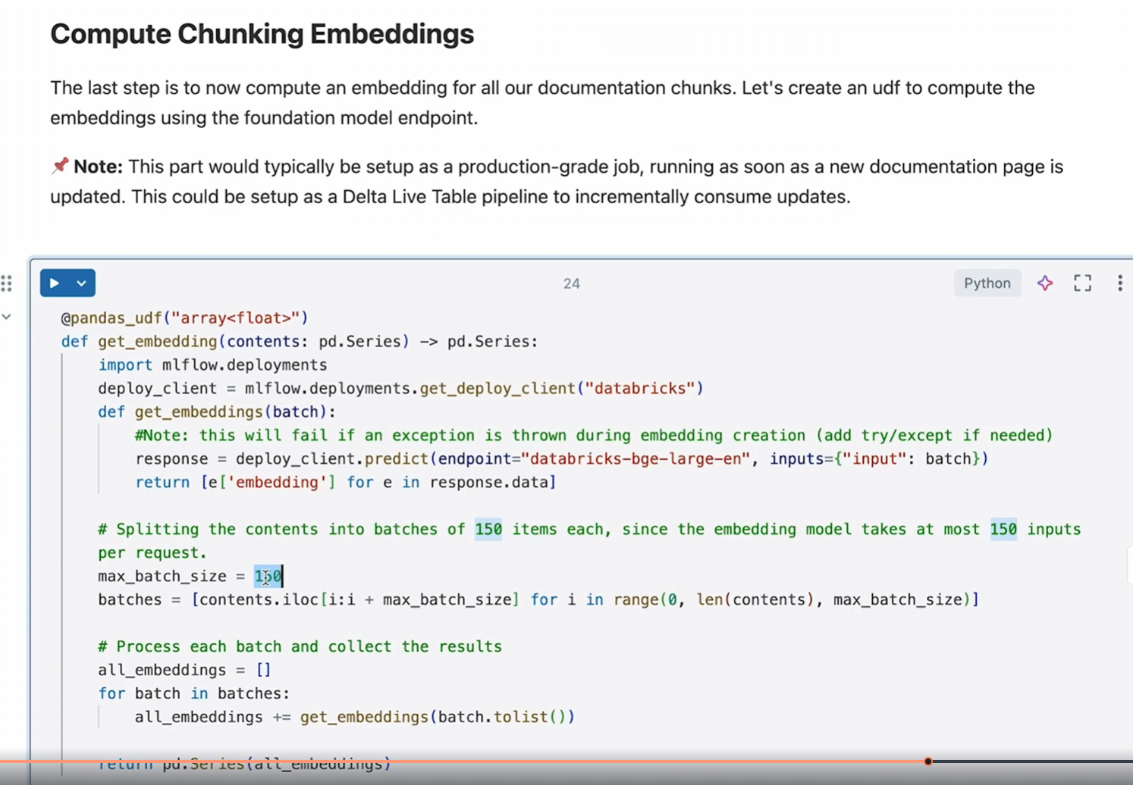



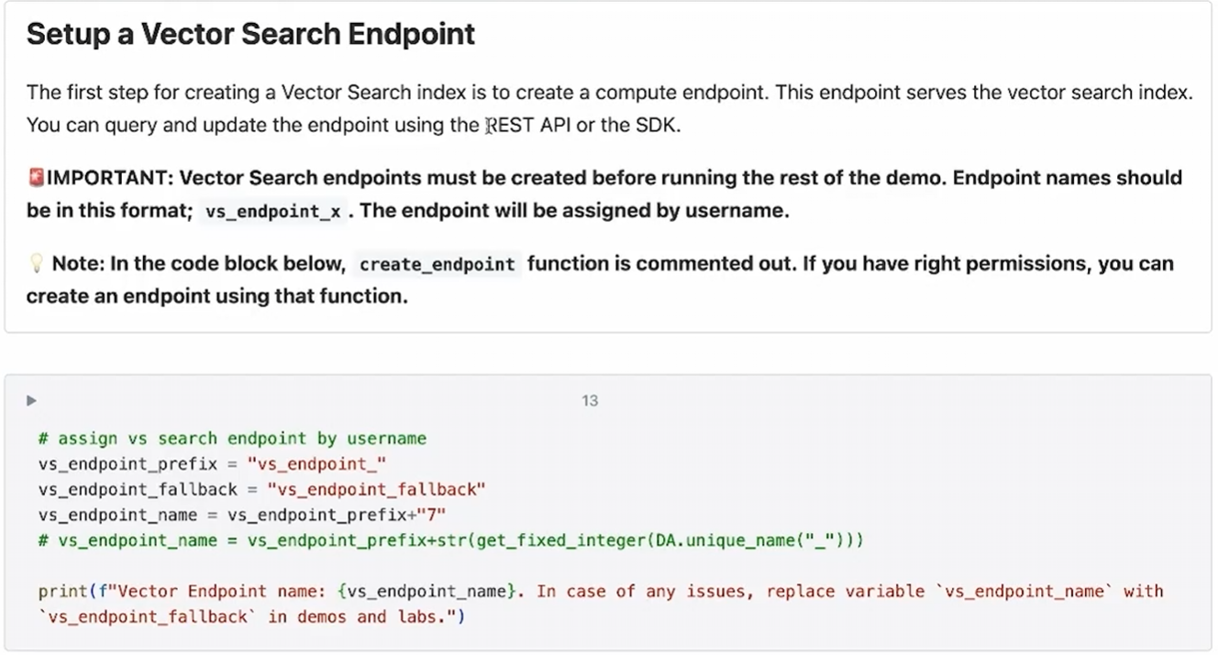

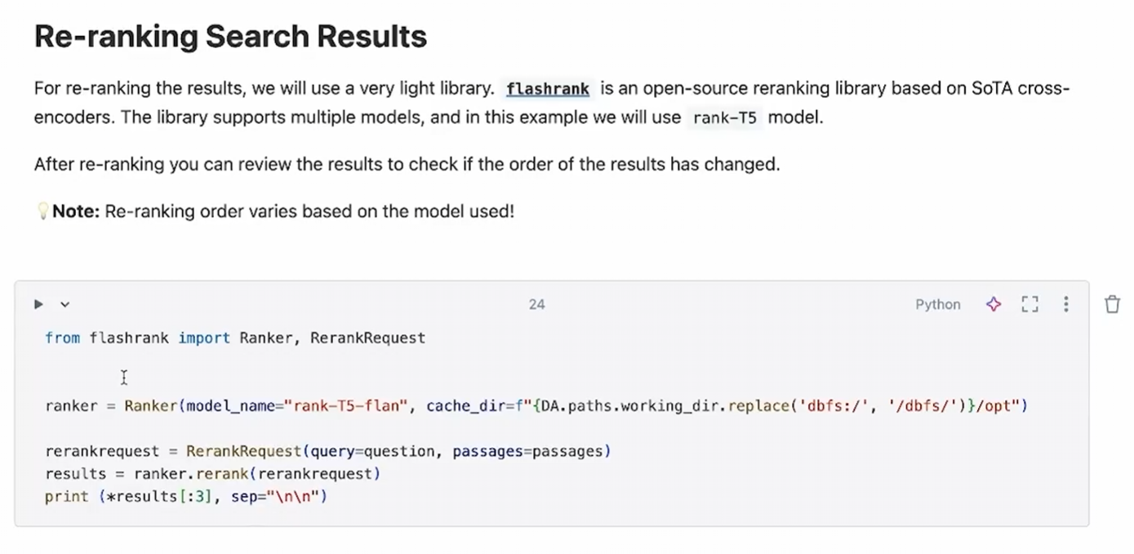

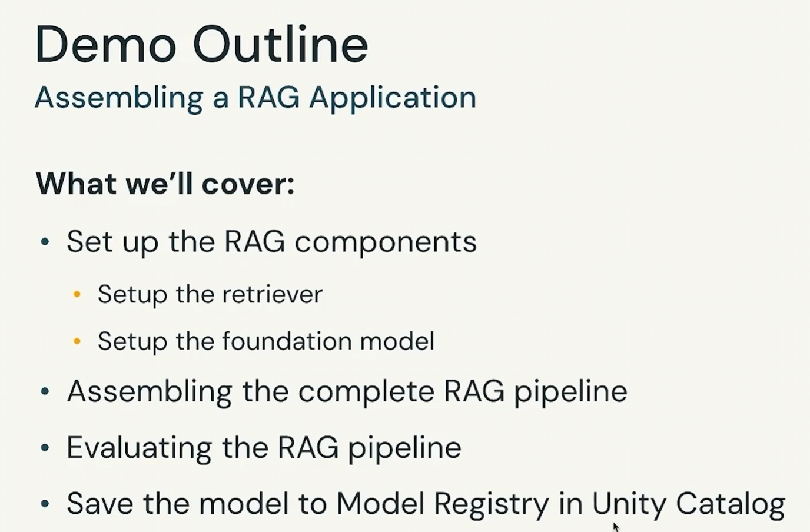

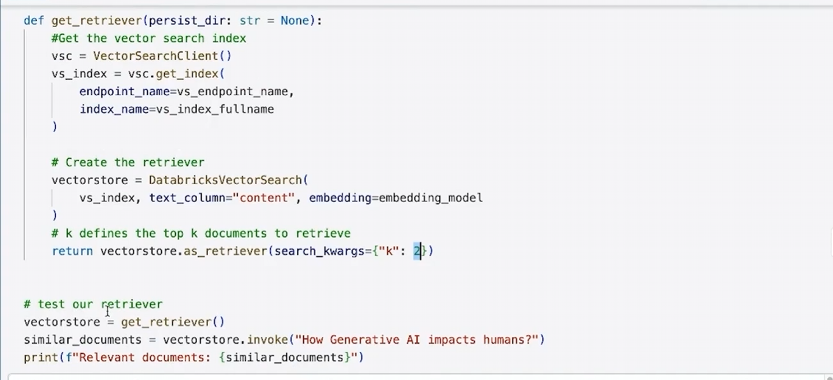

VectorSearchClient

↓

get_index()

↓

Databricks Vector Index

↓

DatabricksVectorSearch (LangChain wrapper)

↓

as_retriever(k=2)

↓

Retriever.invoke(query)

